Bowling League Primer

The purpose of this document is to provide the team with some foundational knowledge regarding the rules of bowling as well as the structure and operation of a typical bowling league. No prior knowledge is assumed.

# **Rules of Bowling**

The idea of bowling is simple: roll a ball down a wooden lane at a set of ten pins arranged in a triangle in an attempt to knock them all down within two throws of the ball. A standard game of bowling takes place over ten turns called **frames**. If a bowler knocks down all ten pins on their first throw, they have achieved a **strike**. If they fail to bowl a strike but succeed in knocking all ten pins down on their second throw, they have achieved a **spare.** Bowling either a strike or a spare in a frame is referred to as a **mark**, while failing to do so is called an **open frame**. A game with no open frames is called a **clean game**. If a bowler achieves a mark on the tenth frame of the game, they get to take one extra throw for a total of three for the final frame.

## Scoring

The objective of a game of bowling is to score the highest possible score one can achieve out of a maximum of 300. When a bowler does not score either a strike or spare, their score for that frame (from 0 to 9 pins) is immediately added to that bowler’s score.



In this example, the bowler knocked down a total of 9 pins and did not score a mark, so the total score is immediately updated to display a total of **9**.



When a bowler scores a spare, their score is not immediately updated. Instead, the scorer **waits** for the bowler’s next throw, then adds that value to the value of spare (**10** pins).



Here, we can calculate the total score as follows:

Frame 1: 9  
Frame 2: 4 + 6 (+ 1) 11

Frame 3: 1 + 5 6

**26**

The value of the first ball of frame 3 is added to the total of frame 2 and the total for that frame is updated.



A strike is scored like a spare, except instead of one throw, the next two throws are added to the striking frame’s total before the total is updated.

Frame 1: X (10 pins) + (X) + (X) 30

Frame 2: X + (X) + (0) 20

Frame 3: X + (0) + (0) 10

Frame 4: 0 + 0 0

Frame 5: 0 + 9 9

**69**

In this scoring scheme, the highest score possible for each frame is 30 points. Since there are 10 total frames, and because of the extra throw granted to a marking bowler on the 10th frames, we get our maximum possible score **30 x 10 = 300**

# **League Play**

All league rules are delegated by the **United States Bowling Congress** (**USBC**). Official sanctioned leagues are split depending on their delegation: **Men**, **Women**, **Senior**, **Junior**, and **Mixed**. Sanctioned leagues bowl once a week, with each bowler bowling three games (referred to as a **series)**. The USBC does not specifically delegate how each league must operate. While there are some rules that apply to all sanctioned leagues, many rules of a league are left to be determined by that league’s governing board. Rules like calculating/applying handicaps, determining legal lineups, absent player scores, and others are voted on by the league captains before the start of the league.

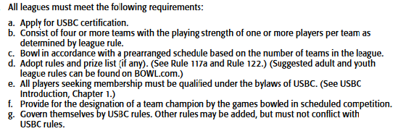

Figure 1: USBC League Requirements

Leagues come in all variety of sizes and have their own internal governance structure. President, Treasurer, and other roles may exist depending on the league, but our role of interest is that of the league **Secretary**. It is the responsibility of the league secretary to collect and organize scoresheets, track total pinfall and league points, calculate averages and handicaps, and track weekly team pairings.

The USBC League Operations Handbook contains a simple form outlining the necessary rules that must be agreed upon by the League during its inception. Rules relevant to our application (excluding rules involving fees and other league bureaucracy decisions) are explained below.

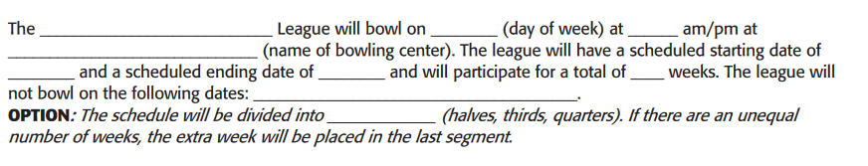

The league must first decide on a schedule.

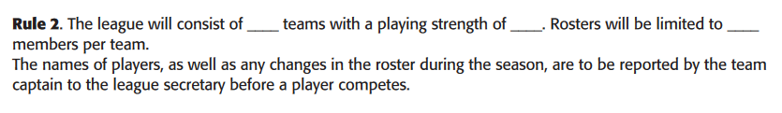

The only real limit to the number of teams a League can field is how many lanes the bowling center has. The smallest the author has personally run is a six-team league, many leagues are much larger. Most leagues have teams between 3 to 5 bowlers. Roster sizes for a team can exceed the number of bowlers that are fielded (extra roster members can be used as substitutes), but total team size is limited.

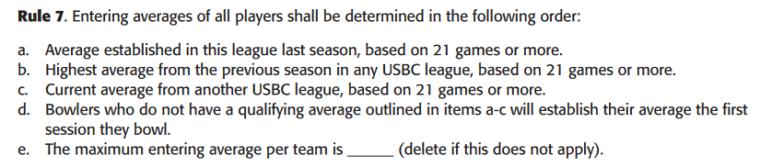

As a bowler accumulates scores from completing league series, those scores are averaged together each week to calculate that bowler’s overall **average**. Each bowler on a league begins the league with an **entering average** that is determined by following the above rule. If a bowler has completed enough games in a previous year in another USBC sanctioned league, their season ending average is used as their entering average at the start of the next league season. Otherwise, their average is established after their first series in a league. Averages play an important role in calculating handicaps, which will be explained below.

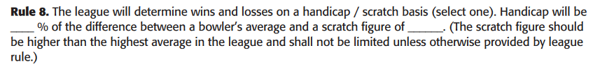

Wins and losses by a team can be determined in one of two ways. The first way is by using bowler’s exact scores without any modifications, also called **scratch** scores. In the interest of leveling competition, most leagues are instead **handicap** leagues. Each bowler has a handicap that is calculated by a formula determined by the league, which is some percentage (usually 70-90%) of the difference between that bowler’s average and some pre-determined high score decided on by the league. When a bowler finishes a game, their handicap is added to their scratch score to calculate their final score.

For example, let’s say we have two bowlers. Bowler A’s average is 180 pins, Bowler B’s average is 140 pins, the league scratch score is 200, and the percentage is 90%. Their handicaps would be calculated as the following:

A .9 * (200 – 180) = .9 * 20 = 18 pins

B .9 * (200 – 140) = .9 * 60 = 54 pins

If instead the league agreed on a higher scratch score, for example 235, both handicaps would become larger.

A .9 * (235 – 180) = .9 * 55 = 49.5

B .9 * (235 – 140) = .9 * 95 = 95.5

Each team member’s handicap is added together to form the total team handicap. After each game, the team handicap is added to the total team scratch score to determine the final team score for that game. This handicap team score is compared against the other team’s handicapped score to determine the winner of that game.

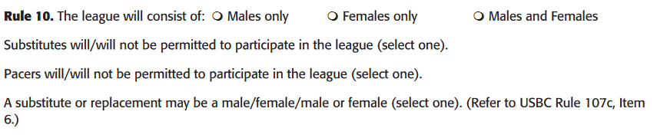

The league determines whether to allow **substitutes** to be swapped in on a team. Leagues can determine whether to allow things like members of other teams substituting on another team roster or whether a bowler must have completed a specific number of games with the team to substitute. **Pacers** are extra bowlers used in situations when teams have mismatched roster sizes. They bowl with the team who are short members, but their scores are not added to the team score when determining the game winner.



Since it is not a conditional requirement that leagues have an even number of teams, it is possible to have odd numbered leagues with teams that have no competitor each week. Rather than simply award that team with free points, the USBC states that a team must bowl within 10 pins of their team average to win the points for that game. If a team underperforms against their averages while bowling a “ghost” team, it is possible to not win any points for that week.



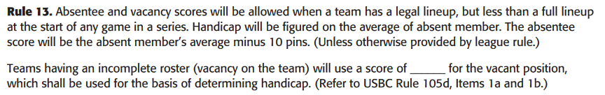

If one or more bowlers are absent from a team but enough members of a team are present to form a legal lineup, rather than simply be given zeroes, missing bowlers instead are given an **absentee** score, which is their average minus ten pins. If a team has enough bowlers for a legal lineup but do not have enough bowlers to form a legal lineup, their missing spots can be filled with a pre-determined **vacancy** score.



Points are won and lost on a team basis. The team totals are compared for each of the three games in the series, with points awarded for each game won, and points are also awarded to the highest number of total team pins (including handicap).

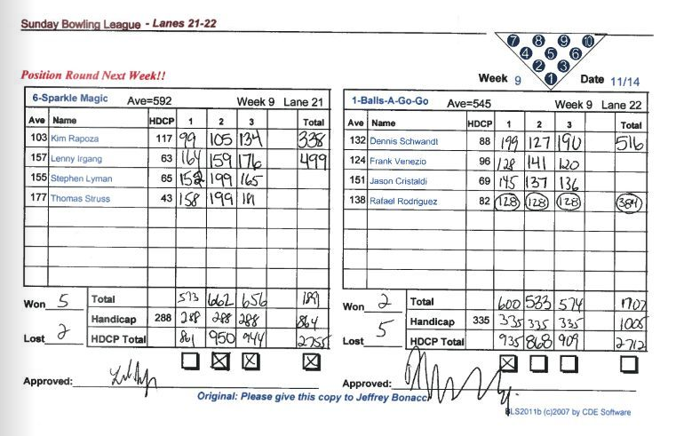

Figure : Bowling League Recap Sheet

The above figure displays a typical recap sheet any league bowler might see. We see the scores for each game recorded for each bowler at the top. Rafael Rodriguez, the last bowler on Balls-A-Go-Go, has his scores circled, which indicates an absentee bowler for that team.

At the bottom on each side, the total number of pins are added for each game in addition to the handicap. The handicap totals at the bottom are compared for each game and the total series, with 2 points being awarded to the winner of each game, and 1 point being awarded to the team with the highest total series. As depicted in the above picture, team Sparkle Magic lost game one with a score of 861 pins to 935 pins but won games two and three 950 – 868 and 944 -909 respectively. They also won the high series total 2755 – 2712. Thus, Sparkle Magic gained 5 team points, and Balls-A-Go-Go 2 points.

# **Relevant Links**

<http://usbcongress.http.internapcdn.net/usbcongress/bowl/rules/pdfs/leagueoperationshb.pdf>

USBC Official League Operations Handbook

<http://usbcongress.http.internapcdn.net/usbcongress/bowl/rulebook/2019-2020Rulebook.pdf>  
  
USBC Official Playing Rules 2019-2020